Raspberry Pi Control of Robotiq Grippers

Version 1.0

23 April, 2025
Last edited by: Jeremy Marvel (jeremy.marvel@nist.gov)

Introduction

This transcript documents the process for setting up a Raspberry Pi as a remote triggering device for opening and closing a Robotiq gripper. The original intention of this process was to enable manual control of the gripper using a simple button press. The source code registers any button press longer than 0.5s as a “press event” to prevent unintentional actuation, and each press event will alternatively open and close the gripper.

The methods described in this document have been tested on both the 3-fingered Modbus Ethernet gripper, as well as the 2-fingered RS485 serial gripper.

Bill of Materials
NOTE: Bill of Materials does not include the cost of the gripper or associated cables. Instead, it reflects only the materials needed to control the gripper with a Raspberry Pi.

Item | Quantity | Example Link & Cost
Raspberry Pi 3B | 1 | $35.00
4GB MicroSD Card | 1 | $8.49
Normally-open momentary switch | 1 | $8.99 (package of 20)
24VDC 10A power supply | 1 | $22.99
5V 3A micro USB power supply (for the Raspberry Pi) | 1 | $9.99
22 Gauge wire (for wiring the button) | 2 spools | $15.20 (package of 2)
Network switch | 1 | $13.95
RJ45 CAT5 Network Cable | 1 | $9.99
OR
USB to RS485 adapter | 1 | $15.35
Modbus Ethernet |  | $124.60
USB to RS485 |  | $116.01

Wiring a Button to a Raspberry Pi
For this setup, we use normally open (NO) momentary switches, with one lead connected to the GPIO pin 2 on the Raspberry Pi, and the other lead connected to the GND pin. For the NIST application, two NO momentary switches were wired in series to force the operator to press and hold both buttons for 0.5s to trigger the gripper actuation.
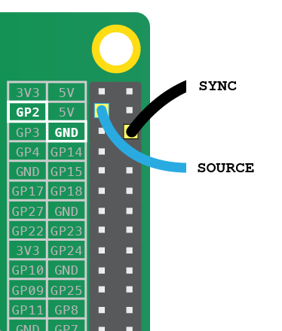

Modbus over Ethernet (Robotiq 3-Finger Gripper)
Installation of the Python libraries

python3 -m pip config set global.break-system-packages true
python3 -m pip install pyModbusTCP

SOURCE
from pyModbusTCP.client import ModbusClient
from gpiozero import Button
import time
import threading
import warnings

class GripperController:
def __init__(self, server_ip, port=502, unit_id=9, update_interval=0.1):
# Initialize Modbus client and update thread
self.client = ModbusClient(host=server_ip, port=port, auto_open=True, unit_id=unit_id)
self.client.open()
self.update_interval = update_interval
self._running = True
self._thread = threading.Thread(target=self._update_loop)
self._thread.start()

def _update_loop(self):
"""Continuously update gripper status."""
while self._running:
self._update_status()
time.sleep(self.update_interval)

def _update_status(self):
"""Update and store the gripper status from Modbus server."""
readData = self.client.read_input_registers(0,8)
if readData:
self.gSTA, self.gIMC, self.gGTO, self.gMOD, self.gACT, self.gDTS, self.gDTC, self.gDTB, self.gDTA = self.stat(self.add_leading_zeros(bin(readData[0])))
self.FaultStatus, self.FingerA_PositionReqEcho = self.Byte_status(self.add_leading_zeros(bin(readData[1])))
self.FingerA_Position, self.FingerA_Current = self.Byte_status(self.add_leading_zeros(bin(readData[2])))
self.FingerB_PositionReqEcho, self.FingerB_Position = self.Byte_status(self.add_leading_zeros(bin(readData[3])))
self.FingerB_Current, self.FingerC_PositionReqEcho = self.Byte_status(self.add_leading_zeros(bin(readData[4])))
self.FingerC_Position, self.FingerC_Current = self.Byte_status(self.add_leading_zeros(bin(readData[5])))
self.Scissor_PositionReqEcho, self.Scissor_Position = self.Byte_status(self.add_leading_zeros(bin(readData[6])))
self.Scissor_Current, RES = self.Byte_status(self.add_leading_zeros(bin(readData[7])))
else:
print("Error reading data in update_status.")

@staticmethod
def add_leading_zeros(bin_num, total_length=16):
"""Ensure binary number string has correct number of digits."""
bin_str = str(bin_num)[2:] # remove '0b' prefix
return bin_str.zfill(total_length)

@staticmethod
def Byte_status(variable: int) -> str:
"""Split and parse byte status."""
B1 = int(variable[0:8],2)
B2 = int(variable[8:16],2)
return B1, B2

@staticmethod
def stat(variable: int) -> str:
"""Split and parse status."""
# Define gripper modes
modes = ["Basic Mode", "Pinch Mode", "Wide Mode", "Scissor Mode"]

# Split and parse status bits
gSTA = int(variable[0:2],2)
gIMC = int(variable[2:4],2)
gGTO = int(variable[4],2)
gMOD = int(variable[5:7],2)
gMOD = modes[gMOD] # Translate mode code to string
gACT = int(variable[7],2)
gDTS = int(variable[8:10],2)
gDTC = int(variable[10:12],2)
gDTB = int(variable[12:14],2)
gDTA = int(variable[14:16],2)

return gSTA, gIMC, gGTO, gMOD, gACT, gDTS, gDTC, gDTB, gDTA

def activate(self):
"""Activate the gripper."""
# response = self.client.write_multiple_registers(0, [self._action_req_variable(rACT=1), 0, 0])
self.client.write_multiple_registers(
0,
[self._action_req_variable(rACT=1, rGTO=1, rMOD=0, rICF=0),
self._position_req_variable(0),
self._write_req_variable(0, 0)]
)
print("Gripper activate")
time.sleep(1)

def command_gripper(self, rPRA=[1, 1, 1], rSP=[250, 250, 250], rFR=[250, 250, 250], rMOD="Basic", rICF=False):
"""Send a command to the gripper."""
# self.status()
modes = {"Basic": 0, "Pinch": 1, "Wide": 2, "Scissor": 3}
rMOD = modes[rMOD]
if rICF:
for var in [rPRA, rSP, rFR]:
if isinstance(var, int):
self.close()
raise ValueError("Input variables must be 3d vectors when using Individual Control Flag.")
response = self.client.write_multiple_registers(
0,
[self._action_req_variable(rACT=1, rGTO=1, rMOD=rMOD, rICF=1),
self._position_req_variable(rPRA[0]),
self._write_req_variable(rSP[0], rFR[0]),
self._write_req_variable(rPRA[1],rSP[1]),
self._write_req_variable(rFR[1],rPRA[2]),
self._write_req_variable(rSP[2], rFR[2]),]
)
else:
for var in [rPRA, rSP, rFR]:
if isinstance(var, list):
warnings.warn("only first value of 3d vector will be used when not using Individual Control Flag.")
response = self.client.write_multiple_registers(
0,
[self._action_req_variable(rACT=1, rGTO=1, rMOD=rMOD, rICF=0),
self._position_req_variable(rPRA[0]),
self._write_req_variable(rSP[0], rFR[0])]
)

def status(self):
readData = self.client.read_input_registers(0,8)
if readData:
self.gSTA, self.gIMC, self.gGTO, self.gMOD, self.gACT, self.gDTS, self.gDTC, self.gDTB, self.gDTA = self.stat(self.add_leading_zeros(bin(readData[0])))
self.FaultStatus, self.FingerA_PositionReqEcho = self.Byte_status(self.add_leading_zeros(bin(readData[1])))
self.FingerA_Position, self.FingerA_Current = self.Byte_status(self.add_leading_zeros(bin(readData[2])))
self.FingerB_PositionReqEcho, self.FingerB_Position = self.Byte_status(self.add_leading_zeros(bin(readData[3])))
self.FingerB_Current, self.FingerC_PositionReqEcho = self.Byte_status(self.add_leading_zeros(bin(readData[4])))
self.FingerC_Position, self.FingerC_Current = self.Byte_status(self.add_leading_zeros(bin(readData[5])))
self.Scissor_PositionReqEcho, self.Scissor_Position = self.Byte_status(self.add_leading_zeros(bin(readData[6])))
self.Scissor_Current, RES = self.Byte_status(self.add_leading_zeros(bin(readData[7])))
else:
print("Error reading data in status.")

def _action_req_variable(self, rARD: int = 0, rATR: int = 0, rGTO: int = 0, rACT: int = 0, rMOD:int = 0, rICS:int = 0, rICF:int = 0 ) -> str:
"""Build action request variable."""
# Check if the input variables are either 0 or 1
for var in [rARD, rATR, rGTO, rACT]:
if var not in [0, 1]:
raise ValueError("Input variables must be either 0 or 1.")
rMOD = bin(rMOD).replace("0b", "").zfill(2)
# Construct the string variable
string_variable = f"0b00{rARD}{rATR}{rGTO}{rMOD}{rACT}0000{rICS}{rICF}00"

return int(string_variable,2)

def _position_req_variable(self, rPR: int = 0) -> str:
"""Build position request variable."""
# Check if the input variables are between 0 or 255
for var in [rPR]:
if var not in range(0,256):
raise ValueError("Input variables must be between 0 and 255.")
rPR = format(rPR, '08b')

# Construct the string variable
string_variable = f"0b00000000{rPR}"

return int(string_variable,2)

def _write_req_variable(self, X: int = 0, Y: int = 0) -> str:
"""Build write request variable."""
# Check if the input variables are between 0 to 255
for var in [X, Y]:
if var not in range(0,256):
raise ValueError("Input variables must be between 0 and 255.")
X = format(X, '08b')
Y = format(Y, '08b')
# Construct the string variable
string_variable = f"0b{X}{Y}"

return int(string_variable,2)

def close(self):
"""Stop the update thread and close the Modbus client."""
self._running = False
self._thread.join()
self.client.close()
print("Connection closed.")

# @brief Main program loop
#
def main():
# Create and activate gripper controller
while ([gripper.FingerA_Position, gripper.FingerB_Position, gripper.FingerC_Position] != target_position):
print(f"FingerA_Position: {gripper.FingerA_Position}")
print(f"FingerA_Position: {gripper.FingerA_Position}")

gripper = GripperController("169.254.116.11")
gripper.activate()

individual_control = False
target_position = [255, 255, 255] # Desired finger positions
speed = [250, 205, 250] # Speed of the movement
force = [250, 250, 250] # Force applied by the fingers
target_position = [target_position[0]] * 3 if not individual_control else target_position

startTime_ = time.perf_counter()
stopTime_ = time.perf_counter()

state = False
time.sleep (0.2)
# Send command to gripper and wait for it to reach final position
target_position = [255, 255, 255]
gripper.command_gripper(rPRA=target_position, rSP=speed, rFR=force, rICF=individual_control)

button = Button(2)

while True:
button.wait_for_press()
startTime_ = time.perf_counter()

button.wait_for_release()
stopTime_ = time.perf_counter()

elapseTime_ = stopTime_ - startTime_
if elapseTime_ > 0.5:
state = not state
if state:
target_position = [0, 0, 0]
else:
target_position = [0, 0, 0]
gripper.command_gripper(rPRA=target_position, rSP=speed, rFR=force, rICF=individual_control)

if __name__ == "__main__":
main()

There are two known issues regarding the use of the Raspberry Pi4B for communicating with the Robotiq grippers over Ethernet; one is a hardware issue, and the other is an OS setting issue when running Raspian based on the Debian GNU/Linux 12 (Bookworm) kernel.

Hardware Issue:
The Pi4B requires an Ethernet cable with all 8 pins of the RJ45 plug connected and wired accordingly.

OS Setting Issue:
By default, the Raspberry Pi4B requires a router that can either set DHCP IP addresses, or “confirm” the static IP address of the Pi. Even if you set a static IP address, the OS will keep “trying” to establish a connection with the LAN, despite that it is visible to other machines on the LAN and can likewise see those other machines. Eventually the OS times out on establishing this connection, and disables the RJ45 port until a new connection is detected.

To bypass this verification step for a static IP address, use the following instructions:

Setting a static IP address (Network Settings (icon on the top-right corner of the desktop) → Advanced Options → Edit Connections)
- Double-click “Wired connection 1”
- Under the “General” tab
  - Set “Connect automatically with priority” to 100 (default is -999)
  - Set “Metered connection” to No
- Under “IPv4 Settings” tab
  - Set “Method” to Manual
  - Add a new static IP address and netmask based on the LAN you are setting up
  - Make sure “Require IPv4 addressing for this connection to complete” is NOT checked (otherwise OS will eventually shut it off since a network switch/hub will not provide verification of IP address)
- Under “IPv6 Settings” tab
  - Set “Method” to Disabled
- Click “Save” button and exit

USB to RS485 Serial (Robotiq 2-Finger Gripper)

Controlling the 2-finger Robotiq gripper is substantially easier, as communications between the Raspberry Pi and the gripper is handled via an RS485 interface.

Installation of the Python libraries

python3 -m pip config set global.break-system-packages true
python3 -m pip install pyRobotiqGripper
python3 -m pip install minimalmodbus

Wiring and Installation

From the Robotiq documentation:

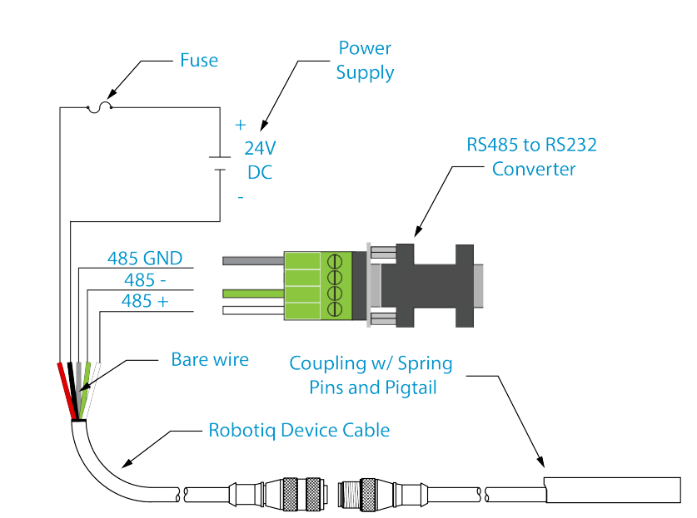

Our configuration did not use an RS232 - RS485 converter, but instead used a USB - RS485 adapter. The wiring at the RS485 side remained the same.

SOURCE
from gpiozero import Button
import pyRobotiqGripper
import time

# @brief Main program loop
#
def main():
gripper = pyRobotiqGripper.RobotiqGripper()
gripper.activate()

startTime_ = time.perf_counter()
stopTime_ = time.perf_counter()

state = False
time.sleep (0.2)
gripper.close()

button = Button(2)

while True:
button.wait_for_press()
startTime_ = time.perf_counter()

button.wait_for_release()
stopTime_ = time.perf_counter()

elapseTime_ = stopTime_ - startTime_
if elapseTime_ > 0.5:
state = not state
if state:
gripper.open()
else:
gripper.close()

if __name__ == "__main__":
main()

